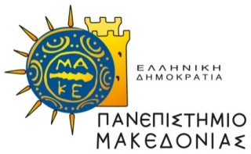 | 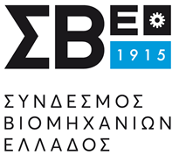

KID-O-NOMICS
Diploma in Economics for Greek Schoolchildren
Economics is at the heart of our understanding about society, social justice and human development. Our ability to understand the basic concepts and ideas in economics provides us the analytical tools to critically judge the activities of governments, organizations and the market place. It is with this in the mind that the University of Macedonia and Federations of Industries in Greece have collaborated to develop the first program in economics for school children: KID-O-NOMICS.
The objective of the program will be to introduce young adults to the fundamental concepts and ideas in economics. The program will aim to be fun and inspiring, and will use a inquiry based teaching approach that will invite students to actively interrogate the ‘nuts-and-bolts’ of economics in everyday life. The course will cover a range of macro and micro economic topics with an emphasis on the application of economic processes in decision making and policy.
The Program will run from November 2021 to May 2022 (every Wednesday 17:00’-19:00’), and be aimed 13-16 year old children.
The cost of the program will be 1,200 Euro.
Classes will be held in the University of Macedonia, the SBE premises and the Athens Stock Exchange premises in Thessaloniki. All safety procedures concerning COVID-19 will be observed at all times.
The curriculum will cover the following topics:
- How do stock markets work?
- Everything you wanted to know about corporate finance, but were afraid to ask.
- What can game theory teach us about decisions?
- Why is economic nudging better than control?
- Is business condemned to be unethical?
- Why is utility useful, and what can it tell us about supply and demand?
- Is Public debt always bad?

Interviews for final admission will be held during September and October 2021.
Application forms (attached) must be sent until the 29th of October 2021,
by email:antmont@uom.edu.gr

for more information:
Anthony Montgomery, PhD
Professor of Work & Organizational Psychology
University of Macedonia Ph: +30 6942400166
Twitter: @monty5429

